TCN4211
Telecommunication Networks

Lab Number 6
Title Configuring DHCP and Examining NAT on a Multifunction Device

Author Name: Anaisy Garcia PID: 5734454

Oct 18



Florida International University

OBJECTIVES:
The objectives of this lab are building a topology containing a wireless router and server, understanding how DHCP enabled networking works, learning how to configure a server, learn to use a complex PDU, learn to connect a multifunction device, and learn about NAT configuration.

EQUIPMENT and COMPONENTS USED
For this lab the equipment used was:
- Laptop
- Cisco Packet Tracer Program
Within the Cisco Program, the components used were three generic PCs, a DHCP enabled wireless router, a router, and a server.

EXPERIMENTAL METHOD AND PROCEDURE
- Build a topology of three PCs and a Linksys-WRT300N.
- Connect each PC to the router using straight through cables.
- Open configuration window on router, go to config tab, change the display anm to DHCP Enabled Router.
- Select the GUI tab and check the default settings.
- Change the IP address of the router 192.168.5.1 and save.
- Change the starting IP address to 192.158.5.26 and save.
- Enable DHCP on PC0, PC1, and PC2 by using the config tab and fastethernet subtab.
- From PC1, ping the router and PC0.
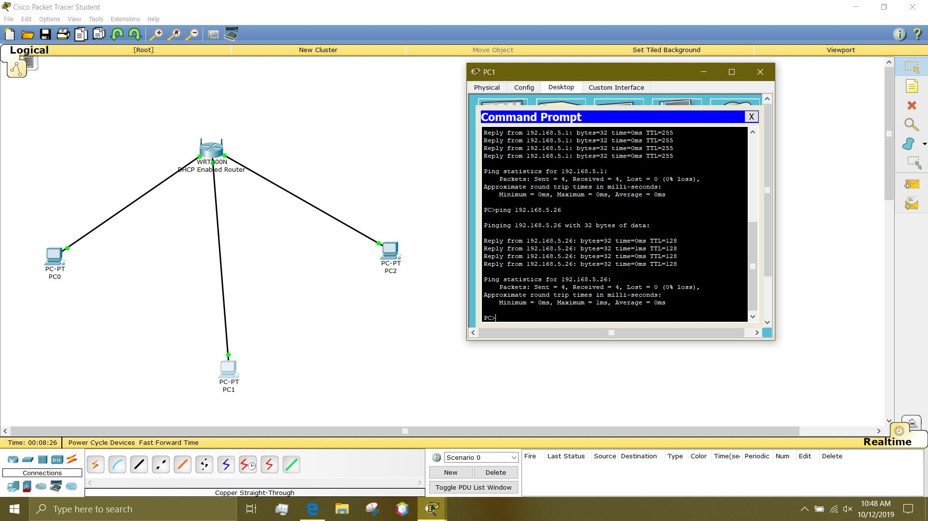
- Add a server and a router to the network.
- Select static IP for Linksys and assign IP addresses.
  - Default gateway: 194.125.5.1
  - IP address: 194.125.5.2
  - Subnet Mask: 255.255.255.0
- Configure the router’s interface addresses:
  - Router>enable
  - Router#config t
  - r1(config)#int fa0/0
  - r1(config-if)#ip add 192.125.5.1 255.255.255.0
  - r1(config-if)#no shut
  - r1(config-if)#exit
  - r1(config)#int fa0/1
  - r1(config-if)#ip address 193.122.3.1 255.0.0.0
  - r1(config-if)#no shut
- Assign static IP address to router:
  - Gateway: 193.122.3.1
  - IP address: 193.122.3.2
  - Subnet Mask: 255.255.255.0
- Ping Server0 from PC0.
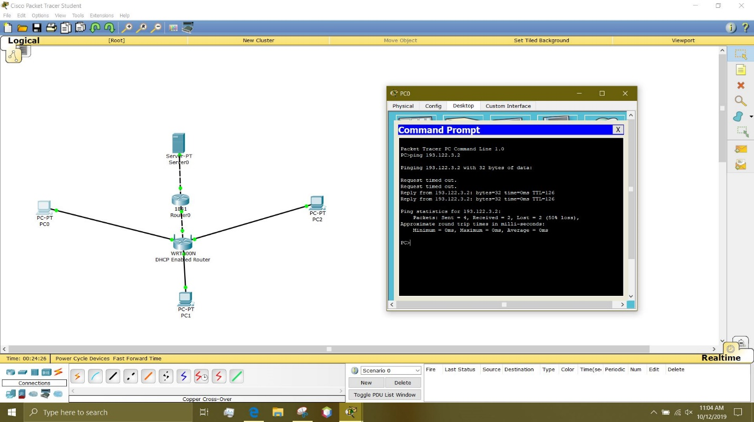
- Enter simulation mode.
- Select Edit Filters then Misc and check only the boxes for TCP and HTTP.
- Add a Complex PDU by clicking the open envelope.
- Click one of the PCs to specify it as the source.
- Create the Complex PDU:
  - Under PDU settings, select application should be set to HTTP.
  - Enter PDU source and destination addresses.
  - Source Port: 1000.
  - Periodic Interval: 120 seconds.
  - Create the PDU by clicking the box Create PDU in the Create Complex PDU window.
- Observe the traffic flow by clicking the Auto Capture/Play button.
- Click the Inbound PDU Details tab.
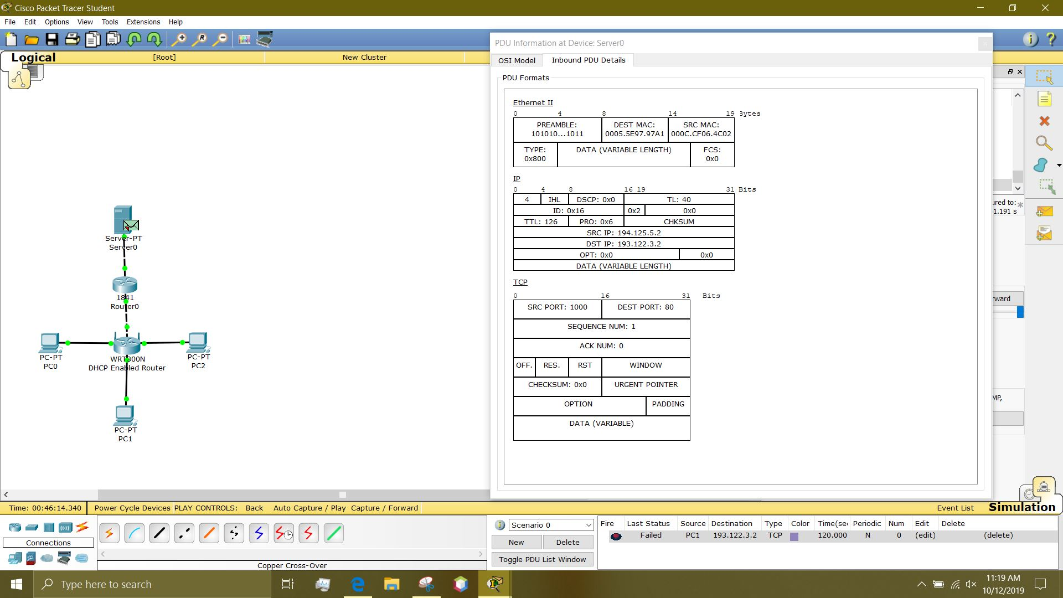
PROBLEMS/QUESTIONS
- The address shown is assigned to the internet port on the Linksys device. Is this a private or public address?
  - The internet port IP address is 194.125.5.1 is a public address.
- Are these private or public addresses?
  - The range of IP addresses shown local area networks are private IP addresses.
- Is the source IP addresses the same as the PC IP address? Explain why?
  - No. The IP address of the PC changed when it went through the router, the reason being is because of NAT. The PC0’s IP address went from private to public.
RECOMMENDATIONS and CONCLUSIONS
This lab consisted of understanding how DHCP enabled routers work and how to obtain an IP when on a DHCP router. This lab also allowed for understanding how to use NAT. Here we also learned how to connect a server to a network. We were also able to see a simulation of how it works with a complex PDU.

